**PROJECT 2: SQL QUERIES**

**Question 2:** For this question you’ll need to use SQL. [Follow this link](https://www.w3schools.com/SQL/TRYSQL.ASP?FILENAME=TRYSQL_SELECT_ALL) to access the data set required for the challenge. Please use queries to answer the following questions. Paste your queries along with your final numerical answers below.

1. How many orders were shipped by Speedy Express in total?
2. What is the last name of the employee with the most orders?
3. What product was ordered the most by customers in Germany?

SOLUTION:

1. How many orders were shipped by Speedy Express in total?

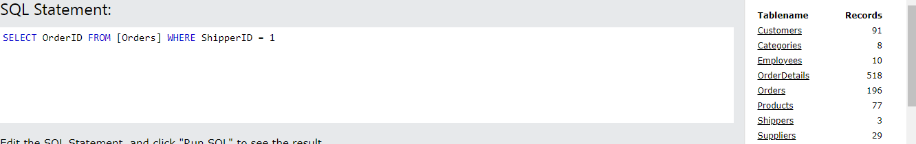

1. What is the last name of the employee with the most orders?

- To get the employee’s last name i need the employee’s ID, and order ID, which are in two different tables, so i will use the sql to extract this two before moving on to extracting the last name.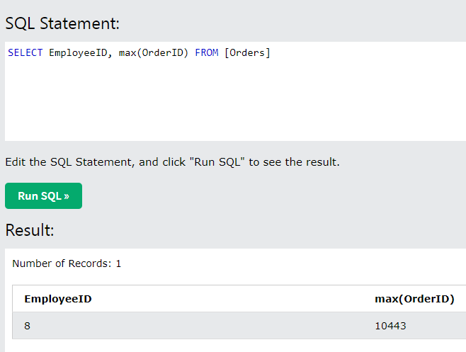

- To get the Employee’s Last name

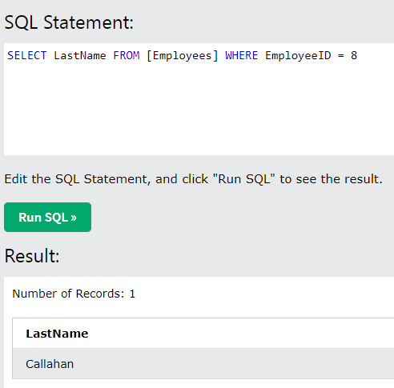

1. What product was ordered the most by customers in Germany?

-To get the most ordered product in Germany, I first query the suppliers table to get the supplier ID which will in turn lead me to the most ordered product by customers in Germany.

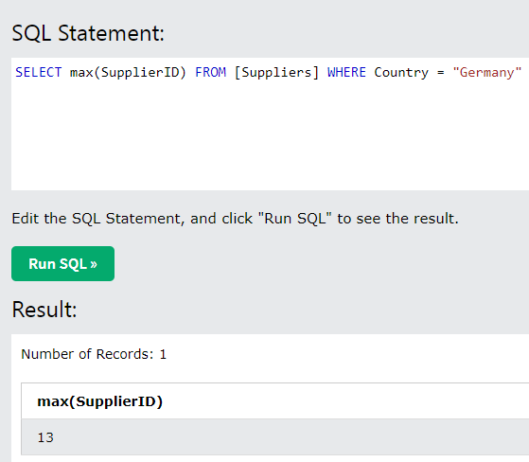

* To get the most product ordered by customers in Germany

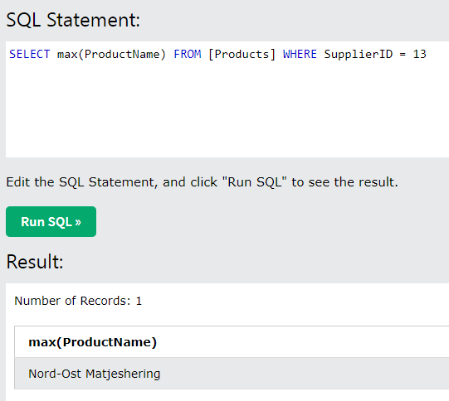

ANSWER:

1. Total orders supplied by Speedy Express = 54
2. The Last name of the employee with the most order is “Callahan”
3. The most product ordered by customers in Germany is “Nord-Ost Matjeshering”